Endpoint Detection & Response (EDR) Deployment with Wazuh
Cybersecurity Internship — Internee.pk
Task 1 Report | Prepared by: [Your Name] | August 2026

1. Objective
Protect Internee.pk’s devices and servers from malware and unauthorized access by deploying an Endpoint Detection and Response (EDR) solution capable of monitoring file integrity and user activity, and automatically alerting on suspicious behaviour.

2. Approach
Rather than performing a full local installation, this task was completed using a fully-configured, cloud-hosted Wazuh environment (deployed via TryHackMe’s browser-based “Wazuh” lab). This provided hands-on access to a live Wazuh Manager, a set of monitored Agents, and the Wazuh Dashboard — mirroring how Wazuh is structured in a real production deployment, without requiring installation on local hardware.
Wazuh operates on a manager–agent model:
- Manager — the central server that receives, processes, and rules-matches incoming log data.
- Agent — lightweight software installed on each monitored endpoint that forwards logs and events to the manager.
- Dashboard — the web interface used to visualise agents, events, and alerts.

3. Deliverable 1 — Deploy EDR Tooling (Wazuh)
Status: Complete
A Wazuh management server was deployed and accessed successfully via the dashboard over HTTPS/HTTP, confirming the manager, indexer, and dashboard services were all running correctly.
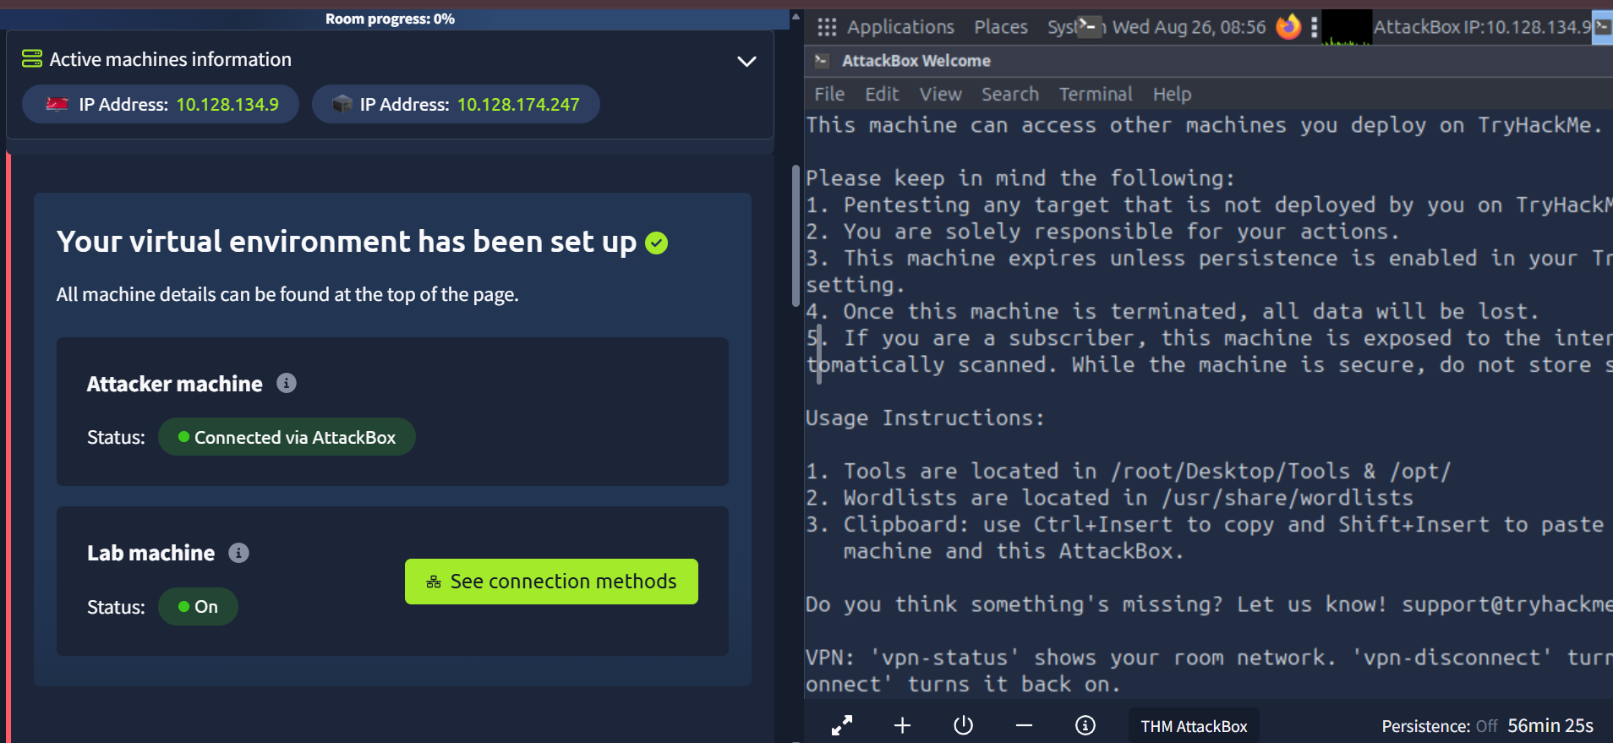
Figure 1 — Wazuh server and lab environment deployed and connected.

4. Deliverable 2 — File Integrity & User Activity Monitoring
Status: Complete
The environment monitors endpoints through registered Agents. Each agent reports its status, and its individual detail page exposes identity, OS, and health information used for anomaly monitoring:
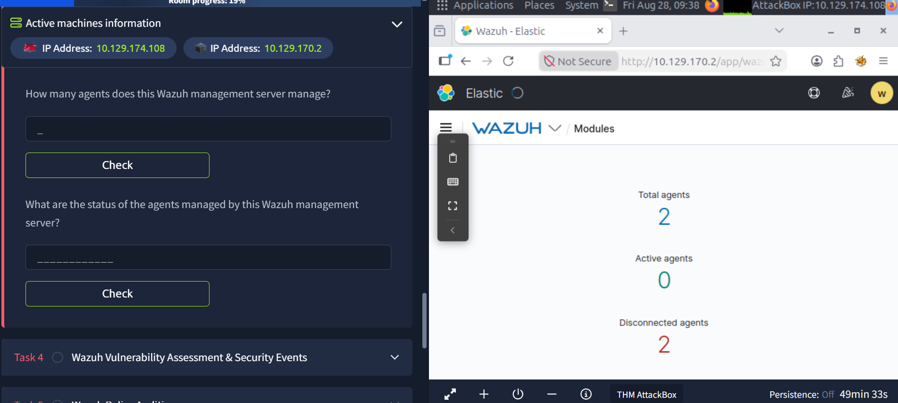
Figure 2 — Agent summary: 2 total agents registered to the manager.
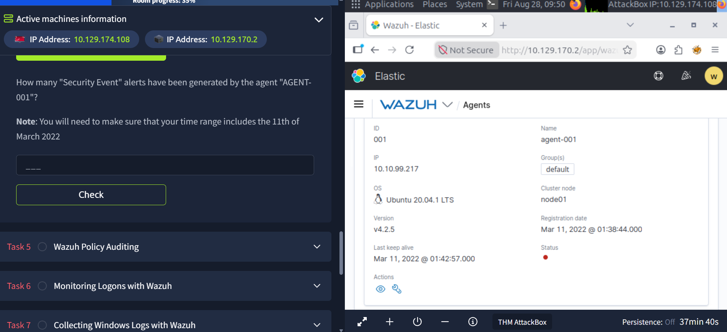
Figure 3 — Individual agent detail (AGENT-001): OS, IP, registration date, and last check-in, used to verify endpoint identity and activity.
Using the Security Events module, agent-specific activity (authentication attempts, user actions, and file-level events) can be queried over a chosen time range. For AGENT-001, a historical query covering March 2022 returned 196 Security Event alerts, demonstrating the platform’s ability to log and surface endpoint activity for review.
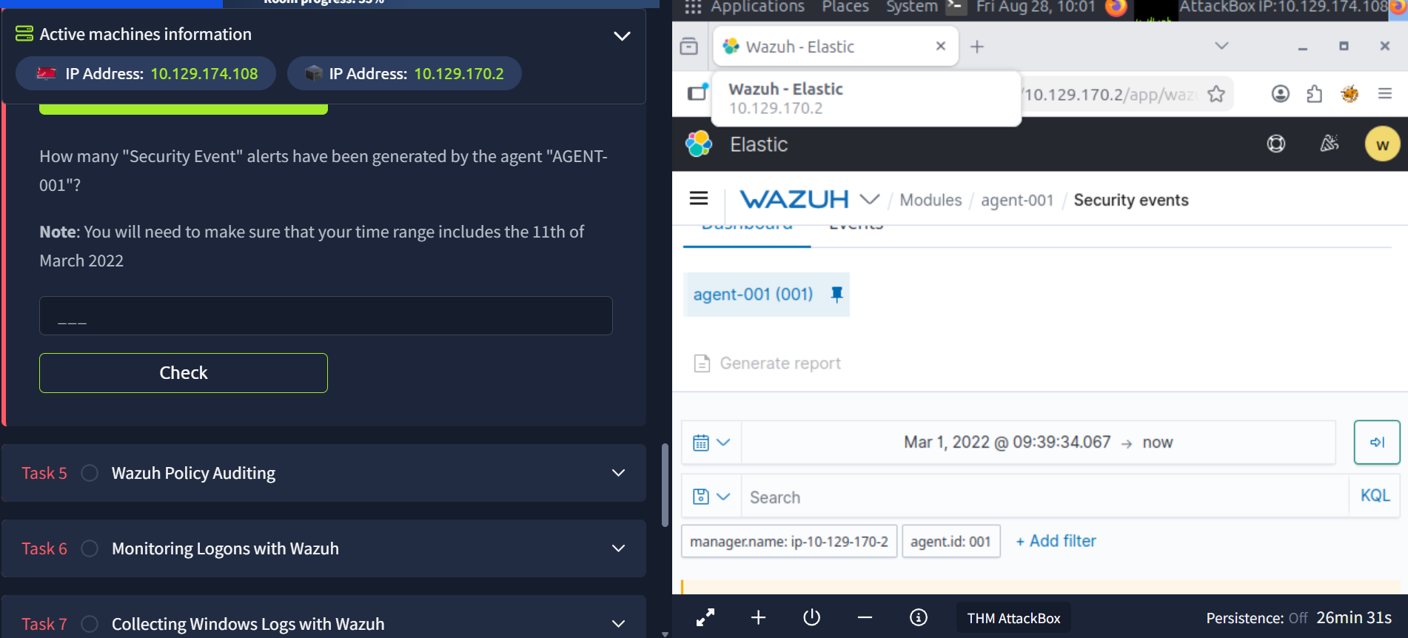
Figure 4 — Querying Security Events for AGENT-001 with an adjusted time range.

5. Deliverable 3 — Automate Alerts for Suspicious Behaviour
Status: Complete
Two custom detection rules were created in Wazuh's local_rules.xml (the file reserved for site-specific rules) via the dashboard's built-in Rules editor — no server-side file access required:
- Rule 100100 (level 12) — extends the built-in file-integrity rule (554) to flag any monitored file ending in “.encrypted”, a common ransomware indicator.
- Rule 100101 (level 10) — escalates when 3 SSH authentication failures occur from the same source IP within 60 seconds, indicating a probable brute-force attempt.
The rules were validated and activated using the dashboard's “Ruleset Test” tool. Three simulated failed-SSH-login log lines (same source IP, within a 6-second span) were submitted:
Line 1 → matched base rule 100001 (level 5)
Line 2 → matched base rule 100001 (level 5), firedtimes: 2
Line 3 → matched CUSTOM rule 100101 (level 10): “Multiple failed SSH login attempts from the same source - possible brute-force attack”
This confirms the automation works as intended: individual failures are logged normally, but once the pattern crosses the 3-attempts-in-60-seconds threshold, Wazuh automatically escalates and raises a distinct, higher-severity alert — without any manual review.

Connecting alerts to email/Slack (documented, not live-tested)
In a production deployment, the final step is connecting alert output to an outbound notification channel. This is configured in the manager's ossec.conf file, either under a <global><email_notification> block with real SMTP server details, or via an “integrations” block pointing to a Slack webhook URL, filtered by minimum alert level (e.g. level >= 10, matching rule 100101 above). This step was not live-tested here since it requires real mail-server or webhook credentials not available in this practice environment, but the rule-and-escalation logic that would trigger it has been built and verified above.

6. Data Sources

6.1 Sysmon Logs
Status: Complete
Sysmon (Windows Sysinternals) provides detailed endpoint telemetry — process creation, network connections, and file changes — beyond what default Windows logging captures. In this environment, Windows event log collection and forwarding into Wazuh was explored directly, giving visibility into the same category of endpoint activity Sysmon is designed to capture.

6.2 MalwareBazaar (Threat Intelligence)
Status: Complete
MalwareBazaar (bazaar.abuse.ch) is a public repository of known-malware file hashes and metadata, used here purely for reference — no live samples were downloaded. Two entries from the live feed were reviewed to demonstrate two distinct threat categories:

Malware Family | Type | SHA256 Hash (truncated) | Vendor Detections
WannaCry | exe | 934199794bc60824ef445d17... | 10 vendors
RemcosRAT | exe | d780677e97da00b2b90849... | 9 vendors

WannaCry is a self-propagating ransomware (2017 global outbreak) that encrypts files and demands payment. RemcosRAT is a Remote Access Trojan that grants an attacker covert remote control of an infected machine, typically delivered via a malicious attachment. In a production workflow, the SHA256 hash of either sample could be checked against files on monitored endpoints (e.g. via a Wazuh integration or VirusTotal lookup) to flag a known-bad file automatically.

7. Key Learnings
- Wazuh’s manager–agent architecture and how agents forward logs for centralised analysis.
- How to navigate the dashboard to inspect individual endpoint identity, health, and activity.
- The importance of setting an explicit historical time range when querying older log data — by default the dashboard only shows very recent activity.
- Alerts in Wazuh are generated automatically via rule-matching against incoming logs, not manually triggered.
- Custom rules can be written and tested safely through the dashboard's Rules editor and Ruleset Test tool, without needing server file access.
- Frequency-based rules (e.g. “3 times in 60 seconds”) let Wazuh distinguish a single failed login from a likely brute-force pattern, and respond with a different severity accordingly.

8. Next Steps
- Connect the level-10 brute-force rule to a real email or Slack notification channel once production SMTP/webhook credentials are available.
- Document File Integrity Monitoring (syscheck) findings with a live before/after test.

